**Docker Task**

**Task Description:**

Install docker on EC2 and explore the docker commands (docker images, containers, volumes, network)

**Techstacks needs to be used :**

* AWS EC2
* Docker

**Docker Setup:**

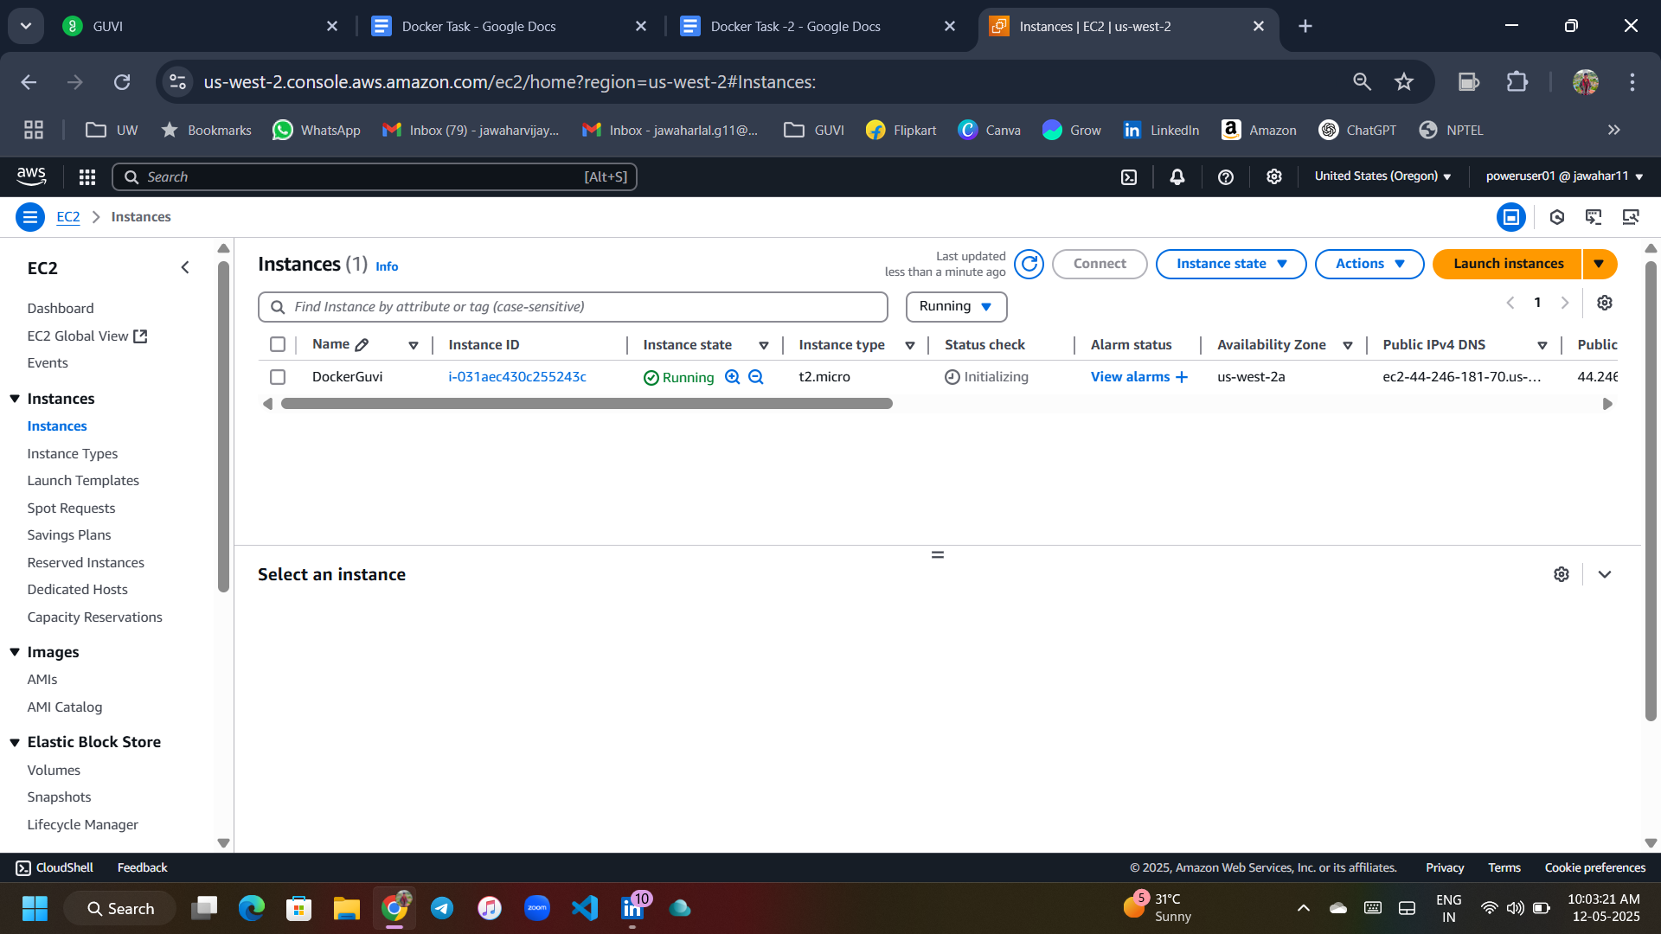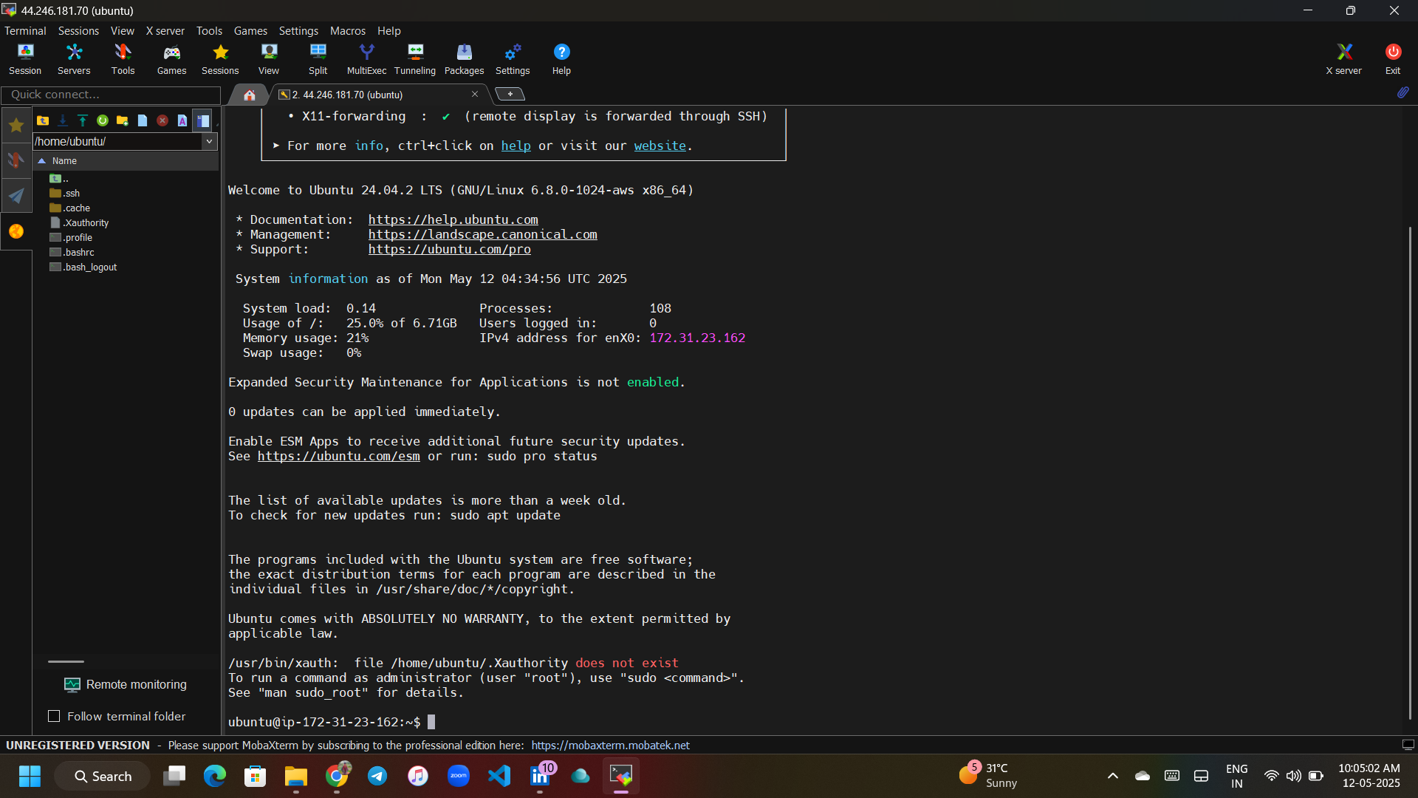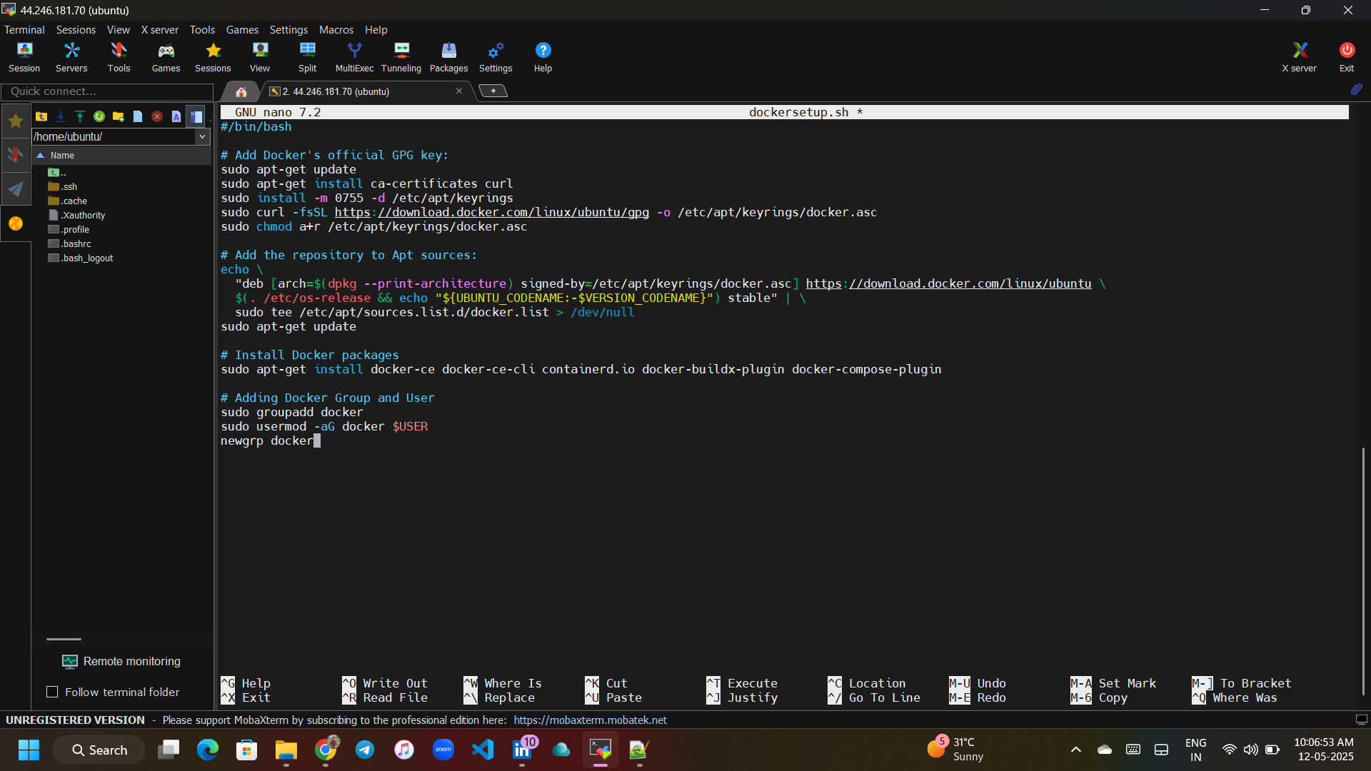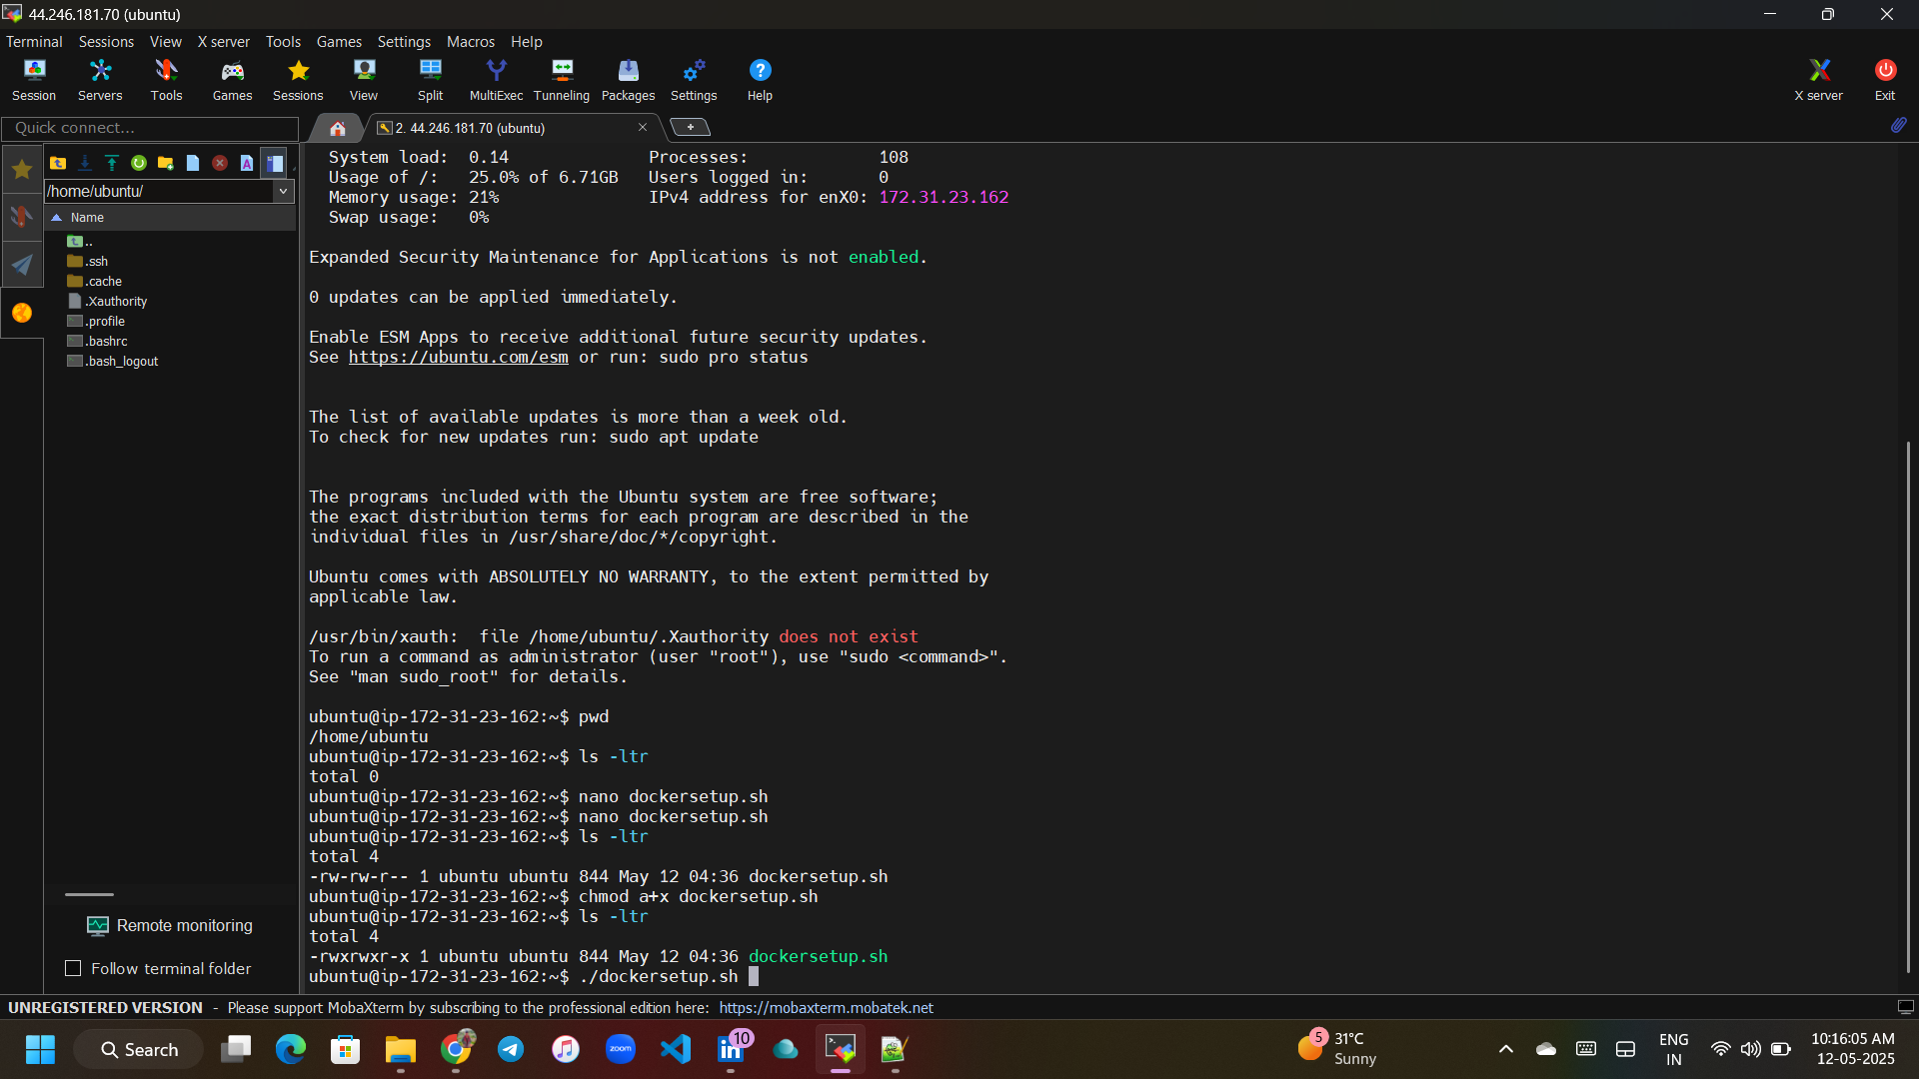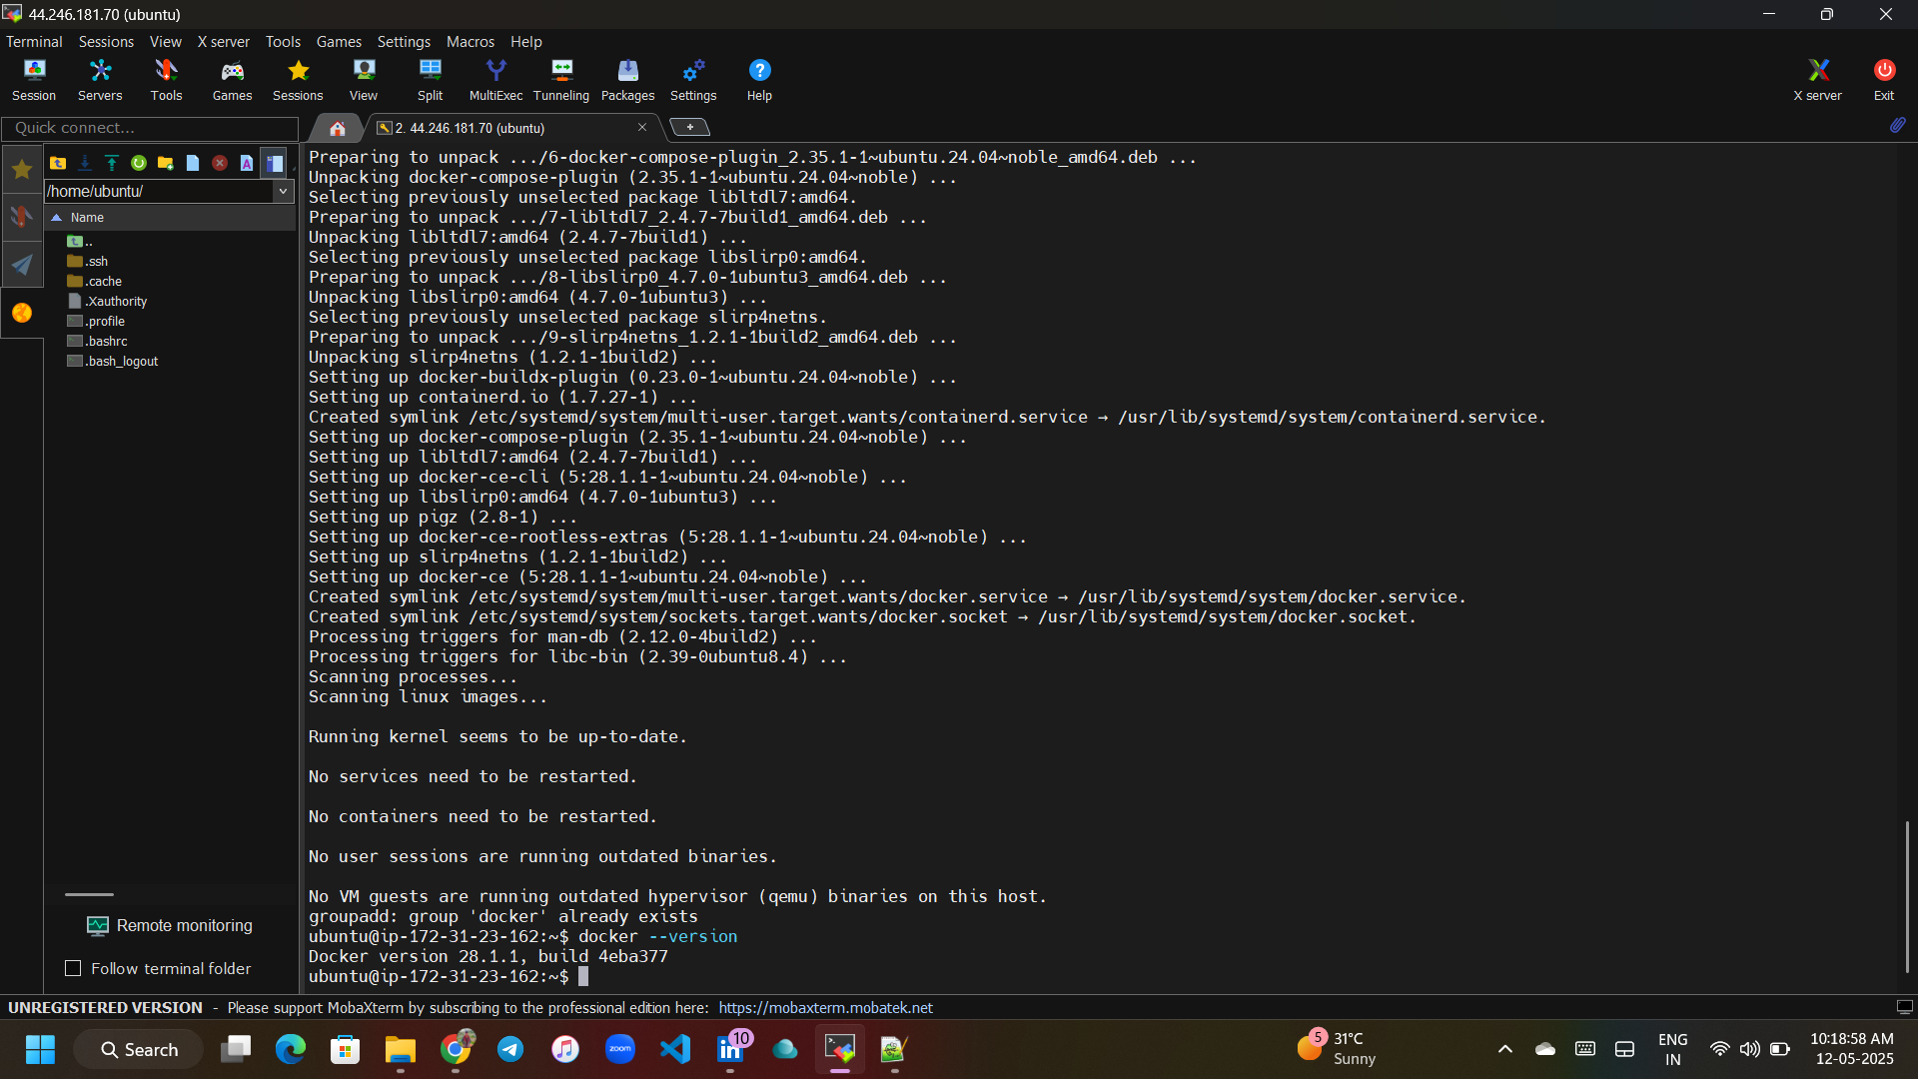

**Docker Images:**

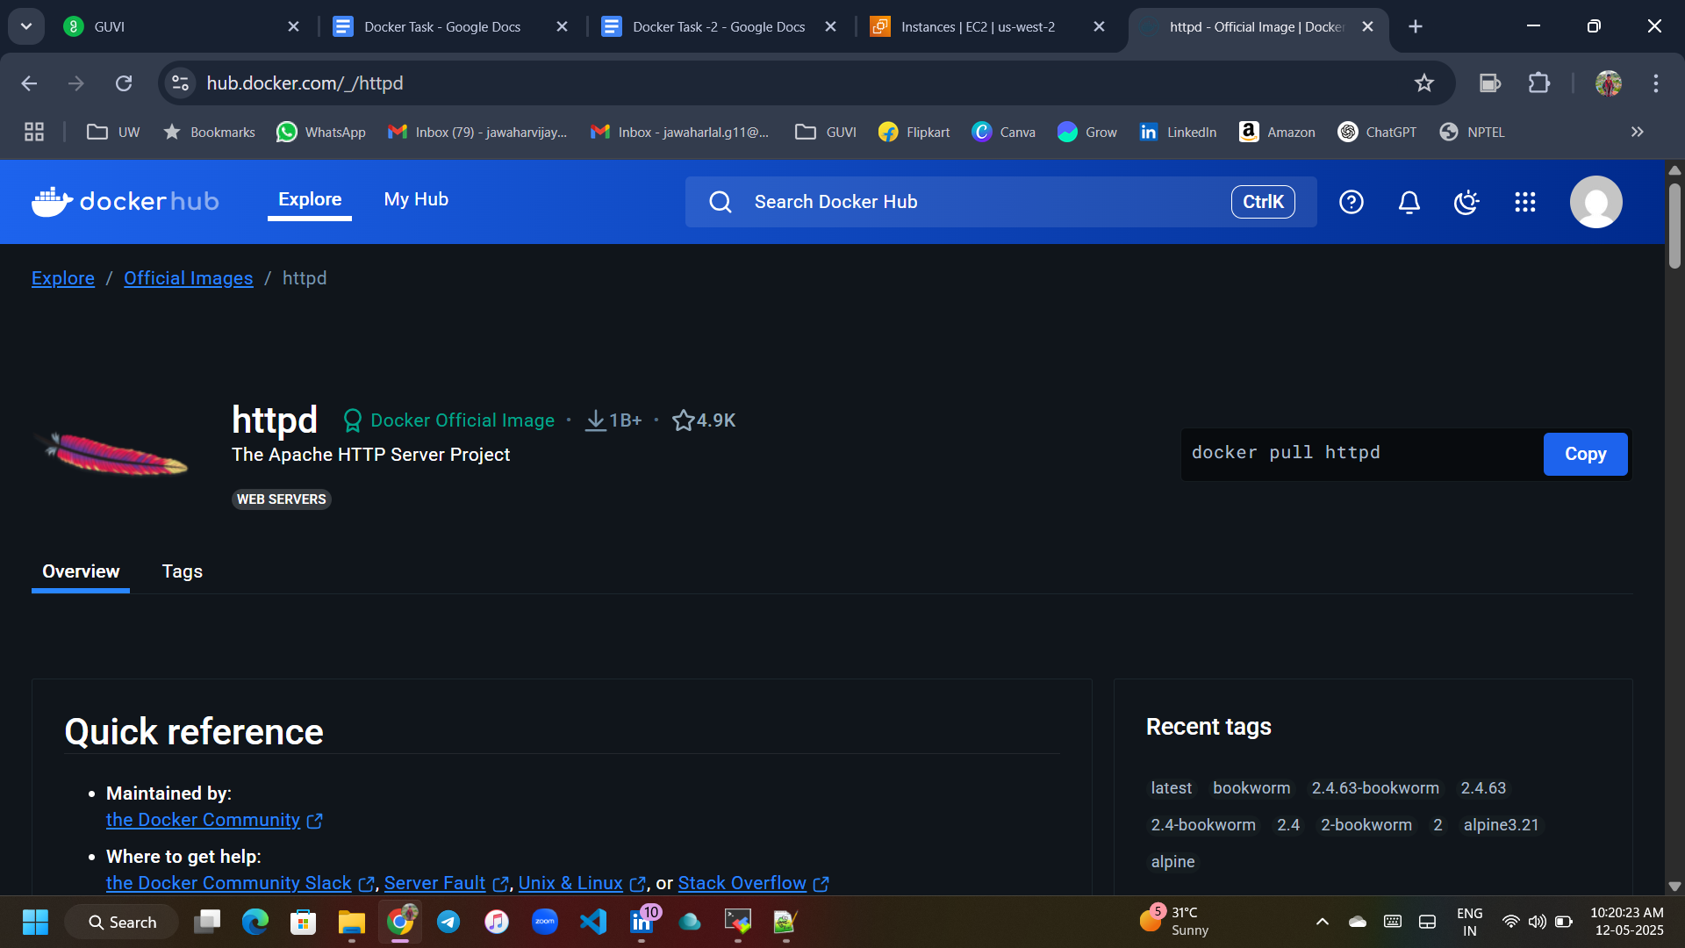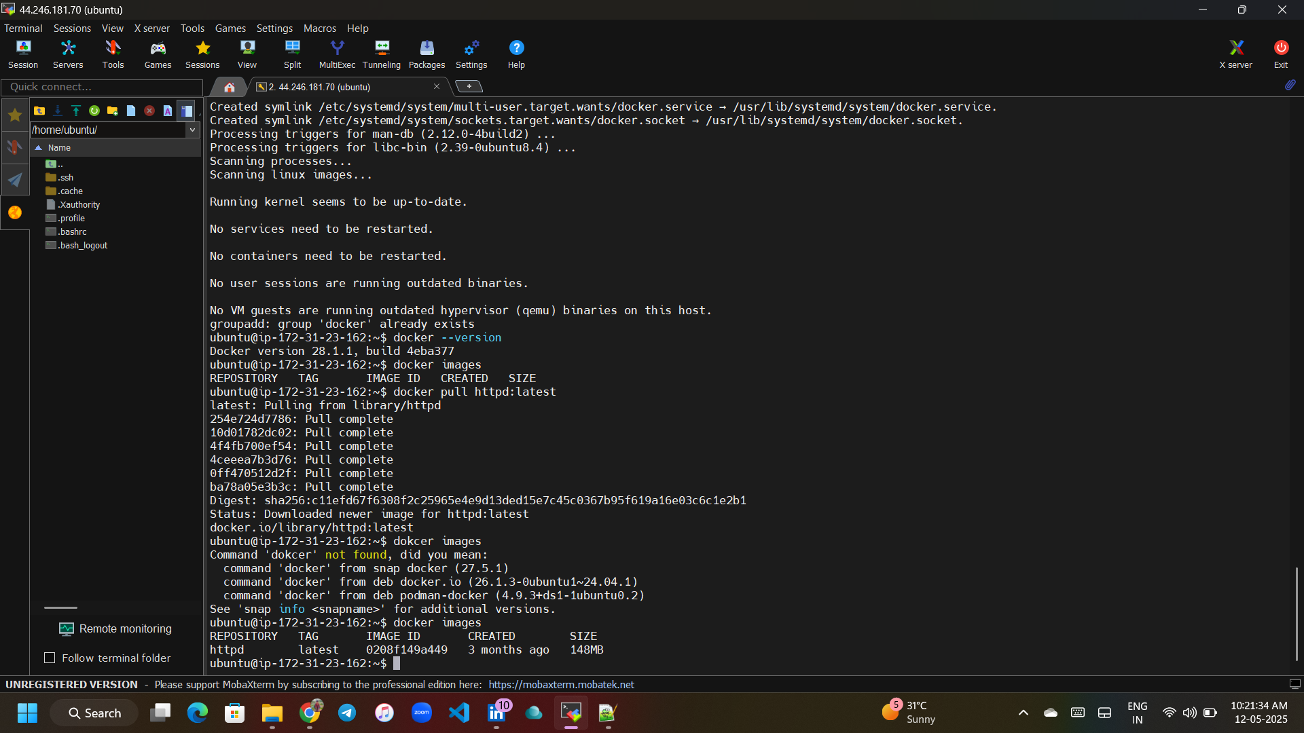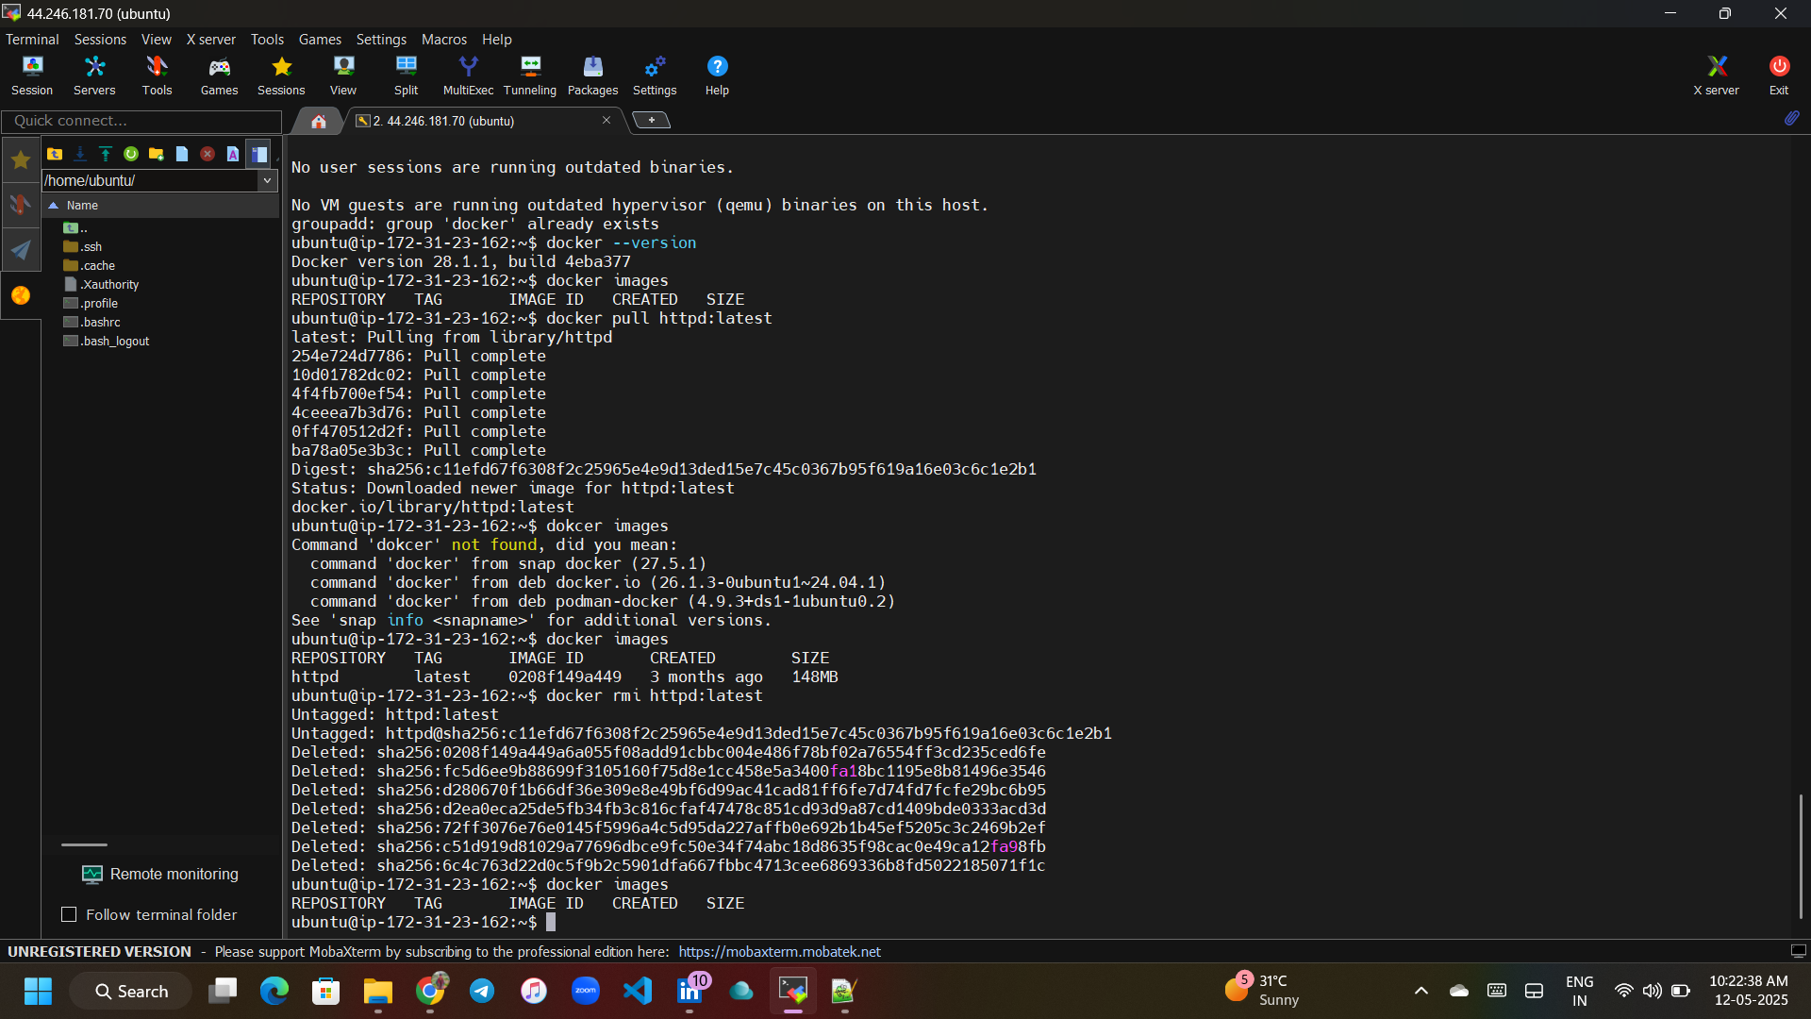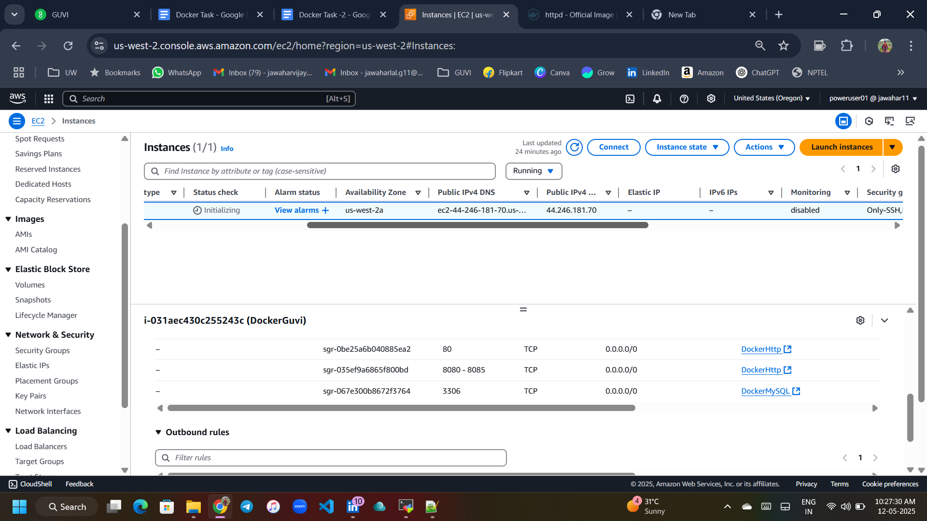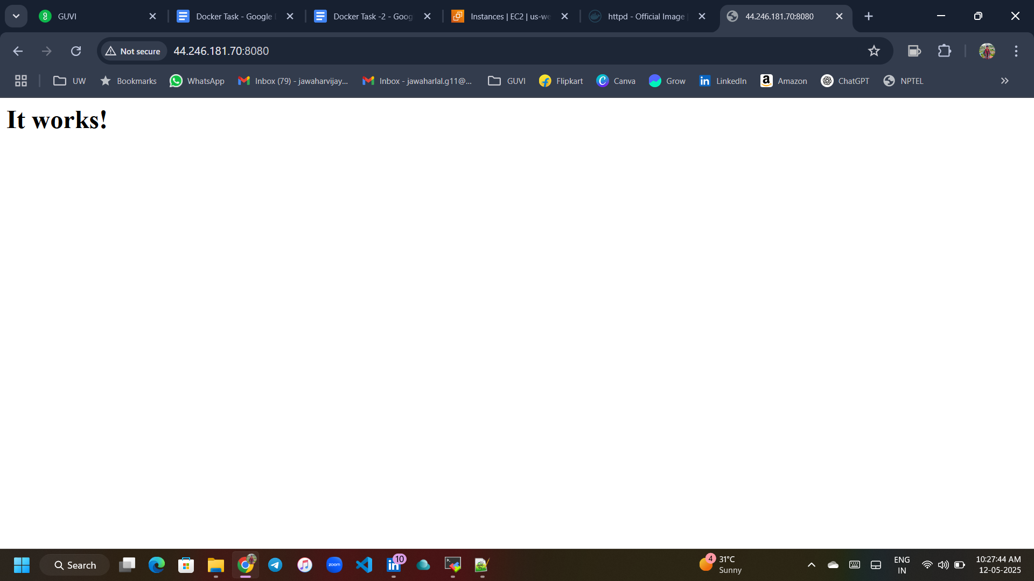

**Docker Containers:**

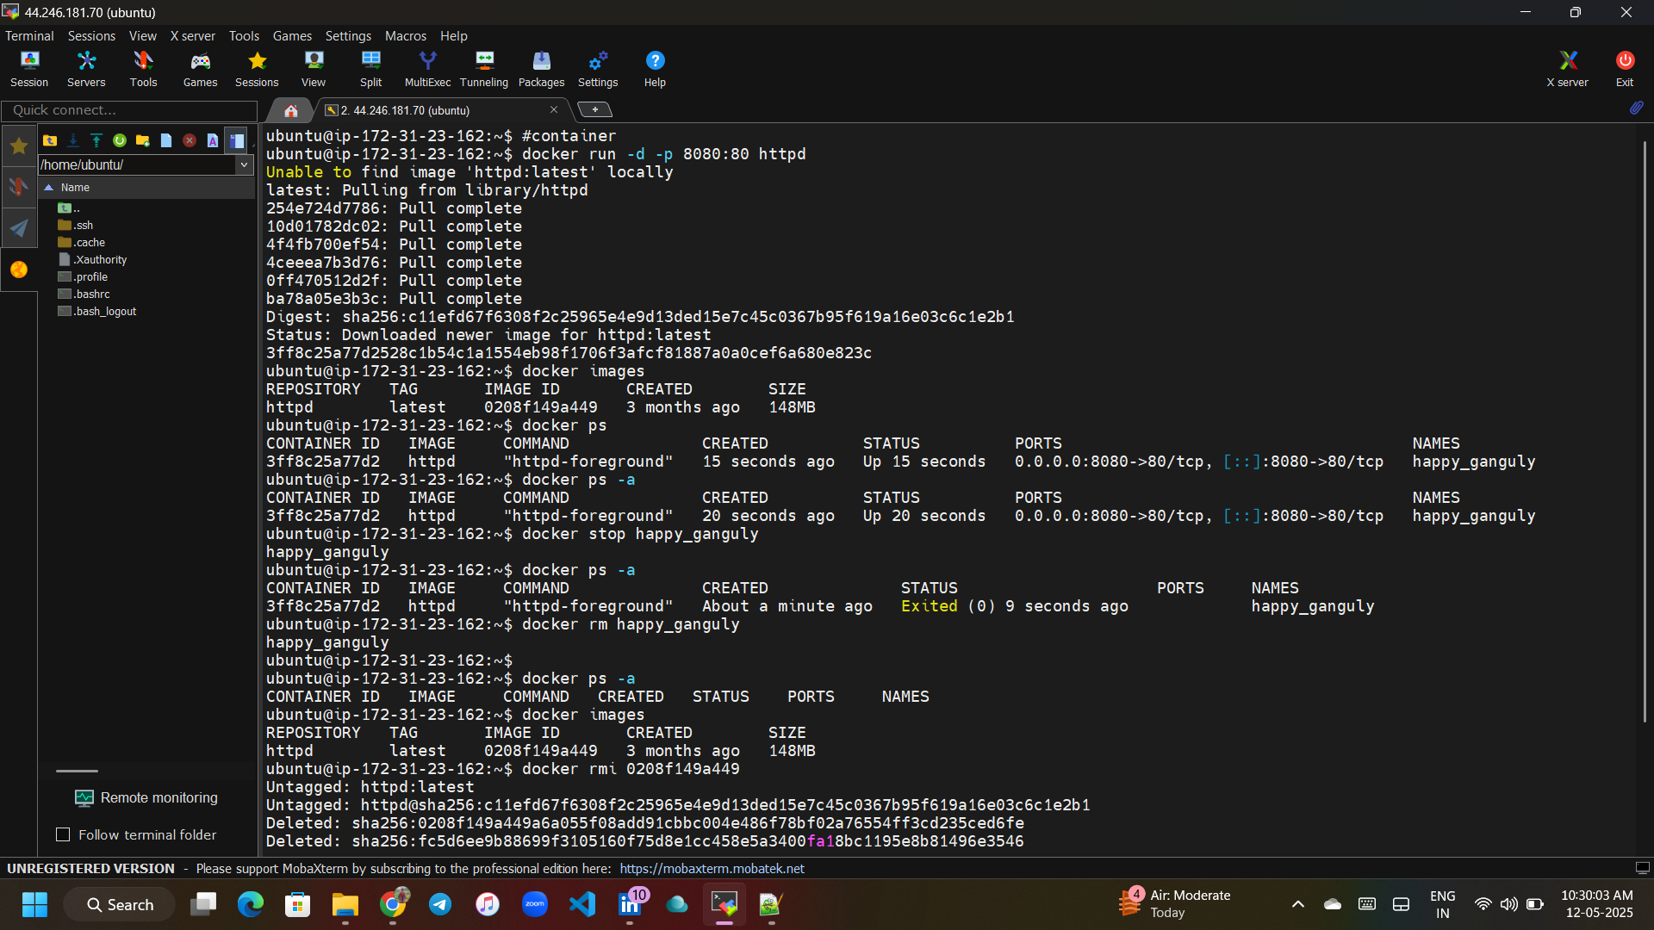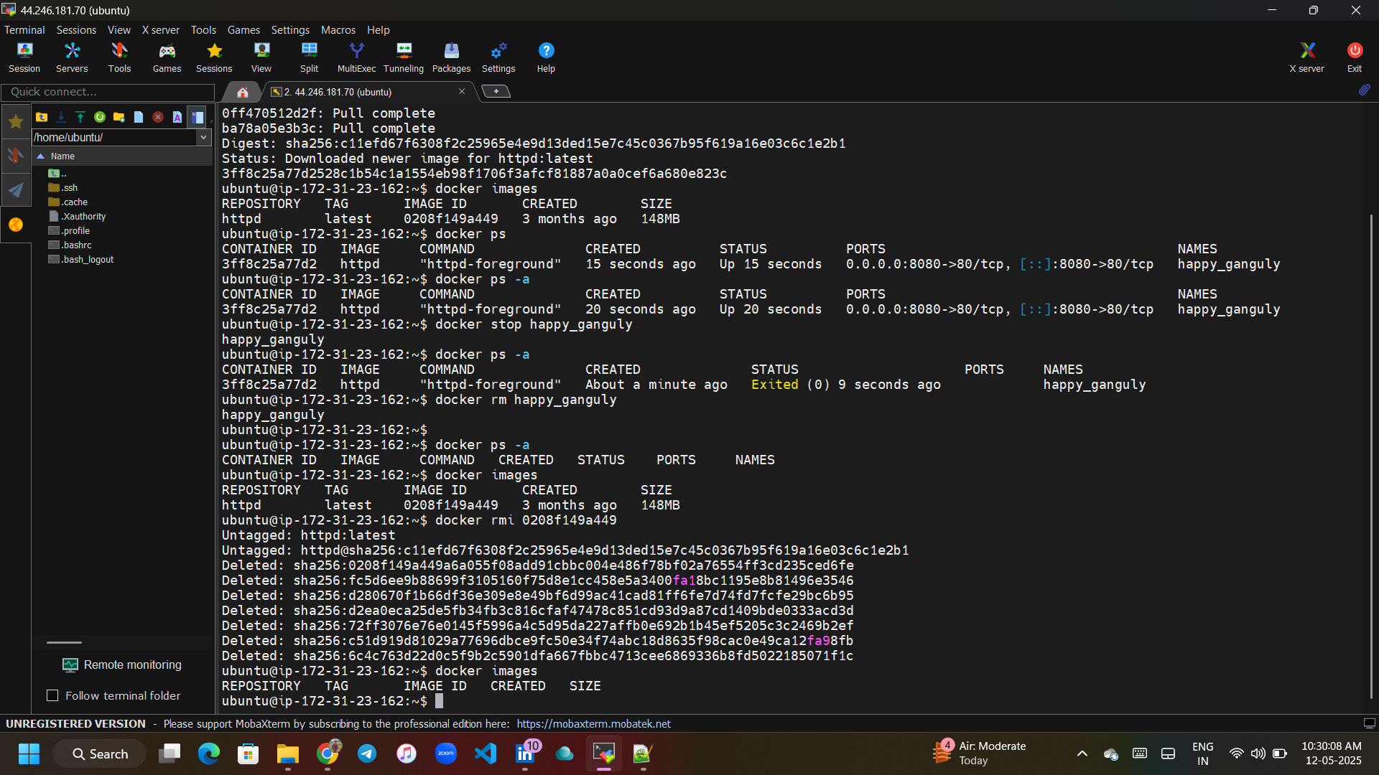

**Docker Volumes:**

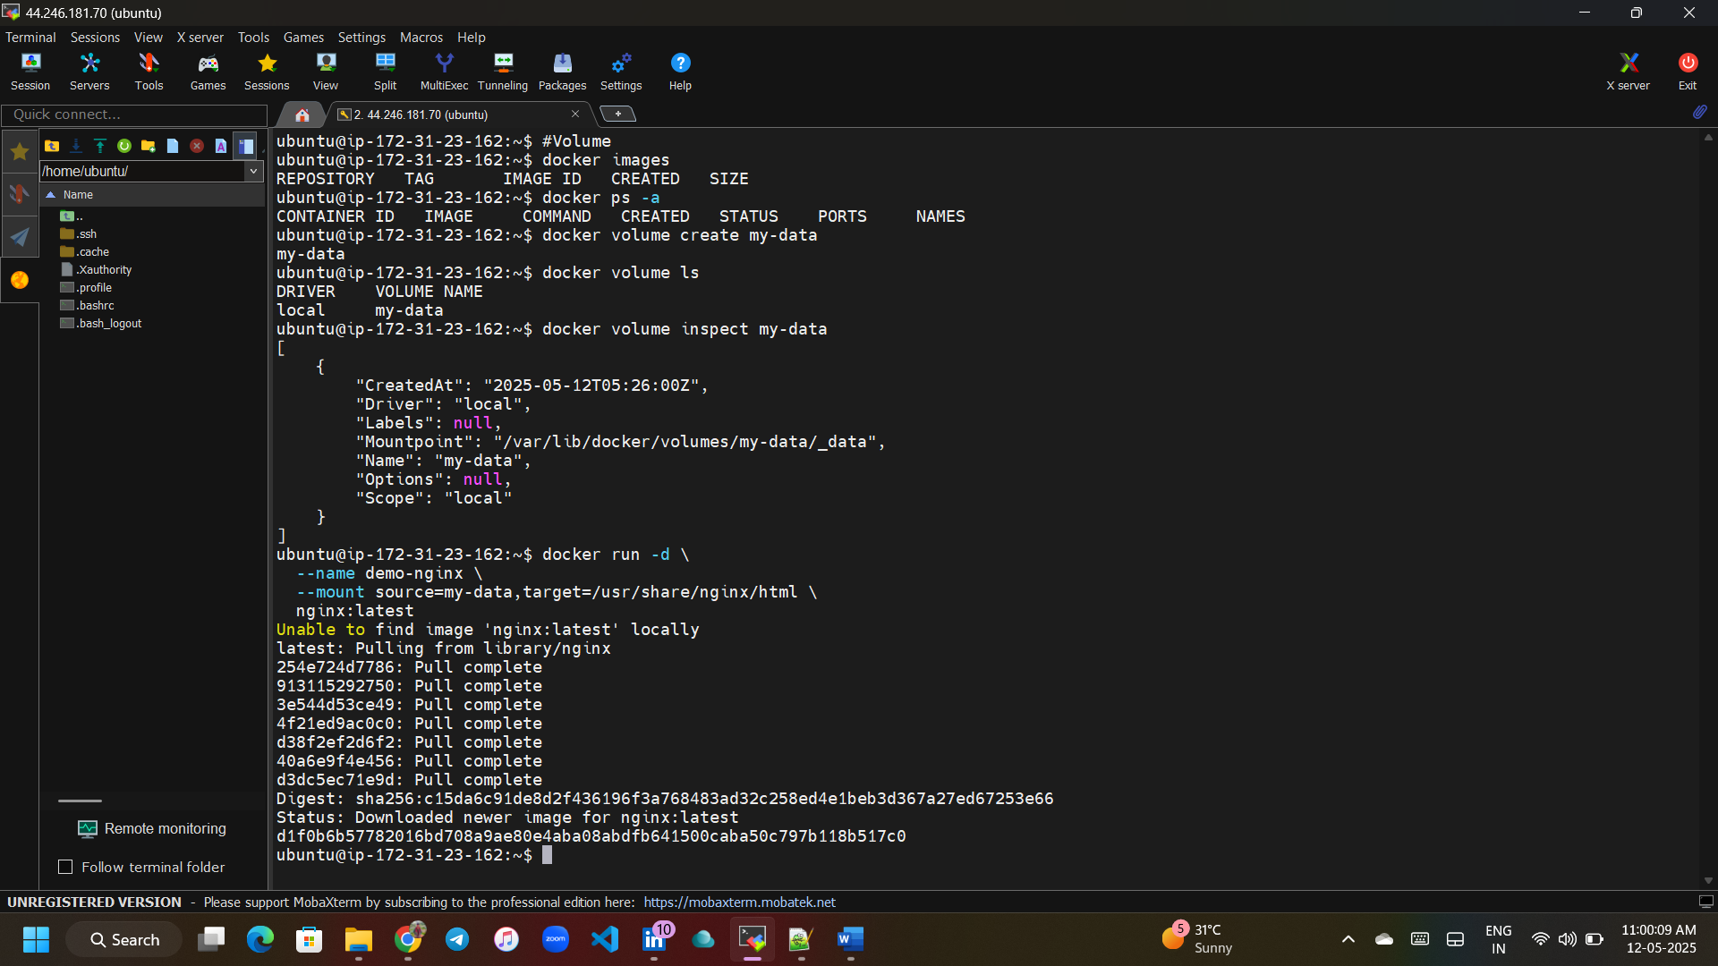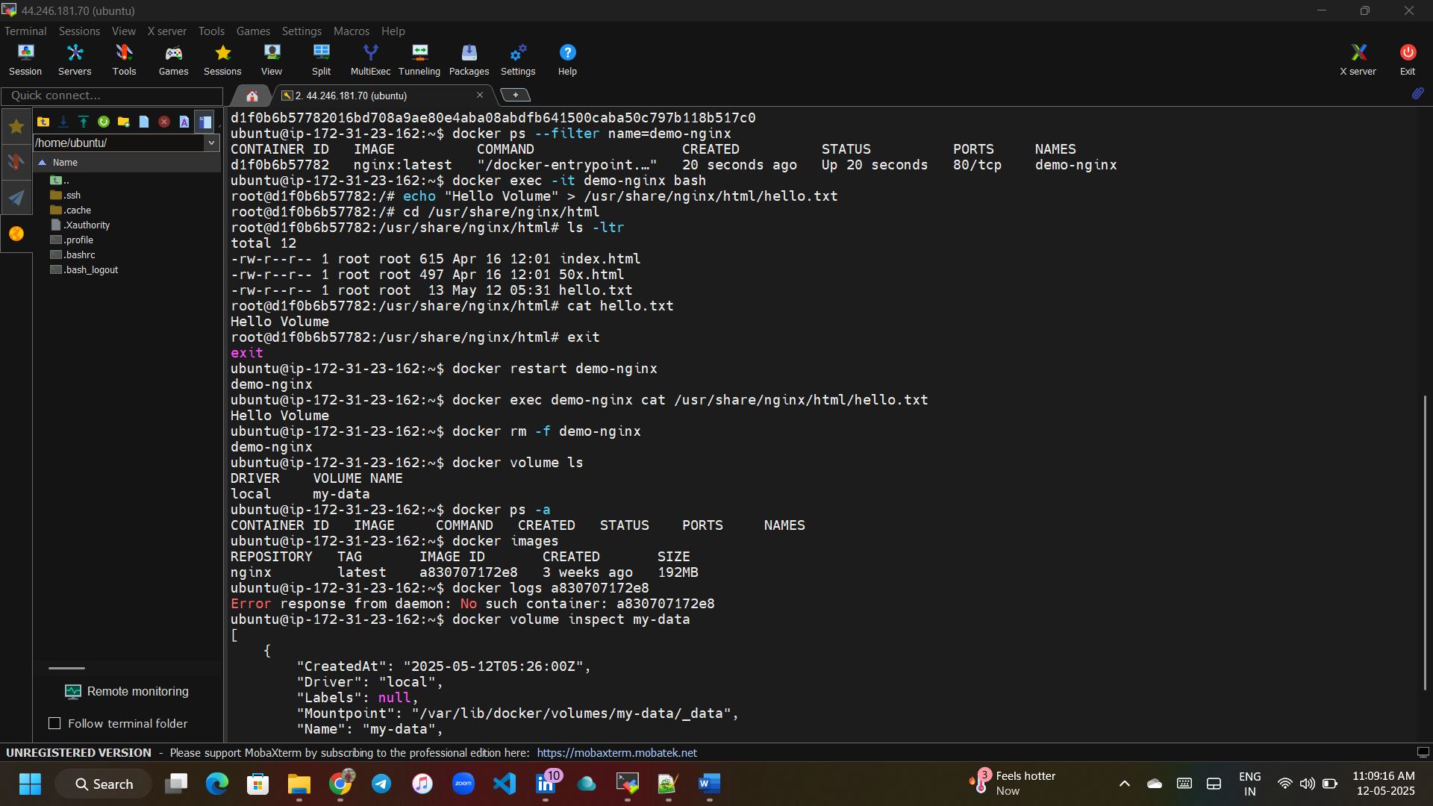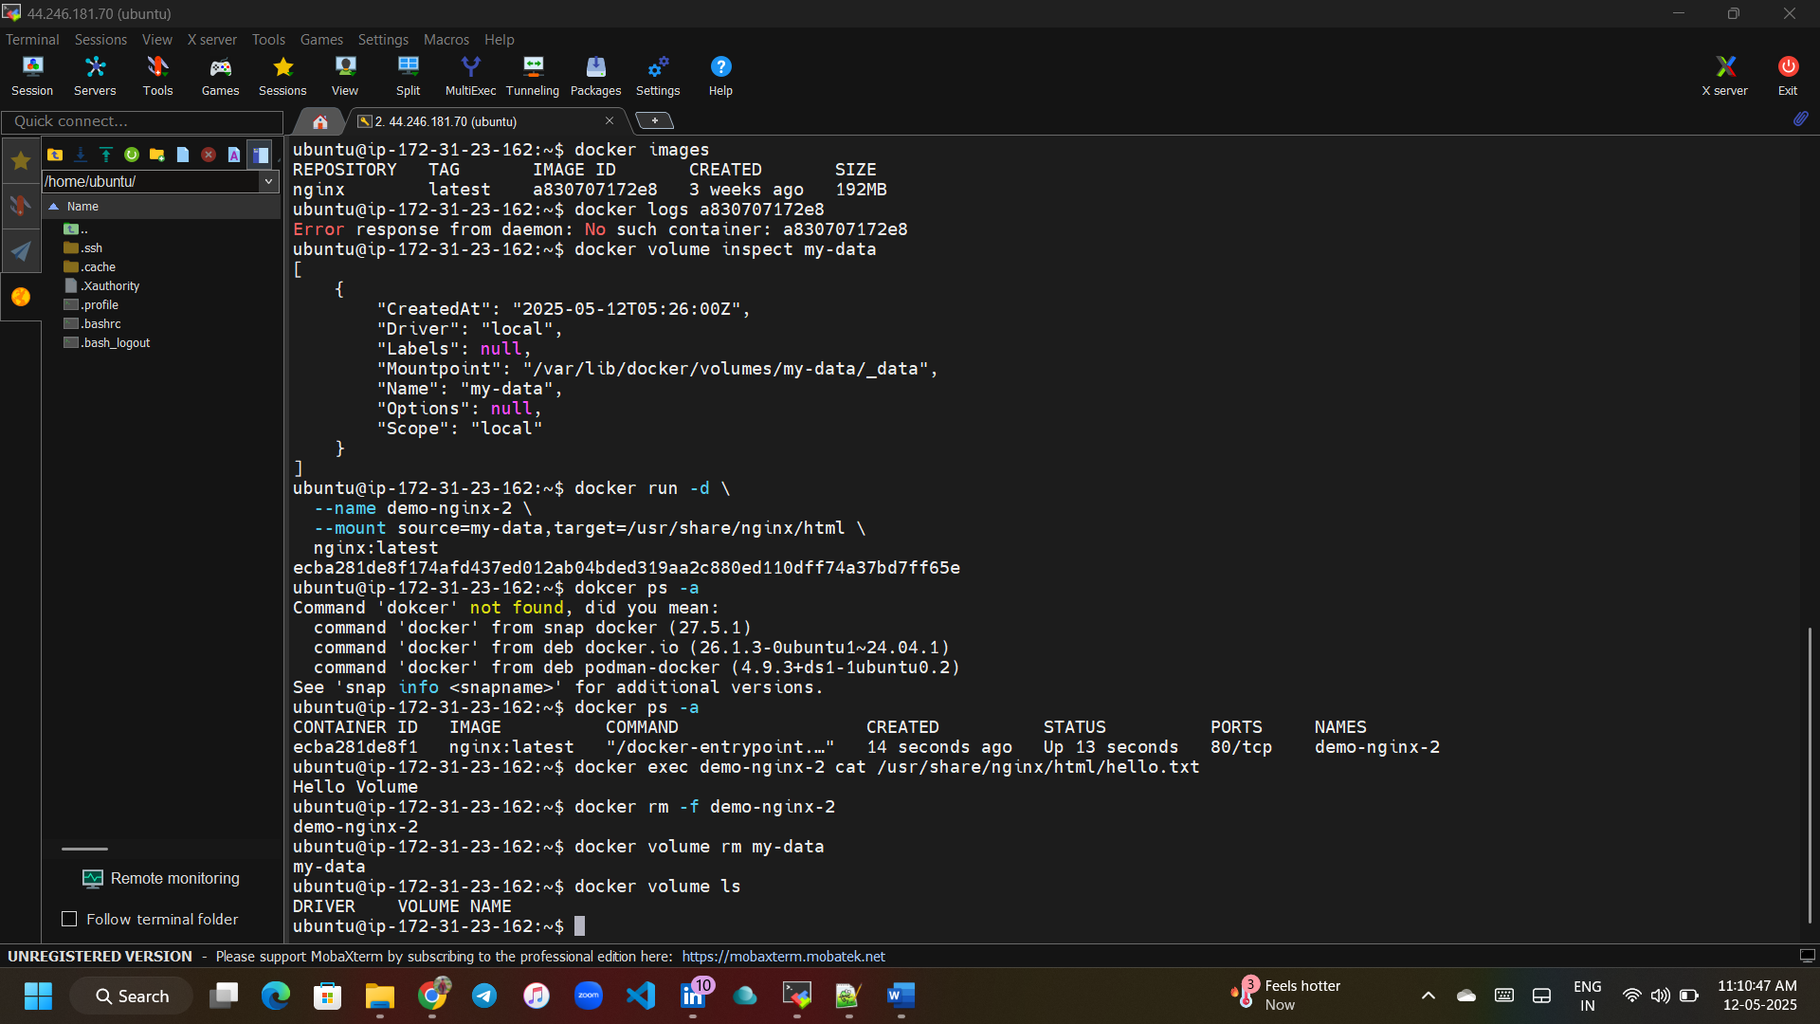

**Docker Volumes: Blind Mount**ubuntu@ip-172-31-20-222:~$ mkdir JawaharVolume

ubuntu@ip-172-31-20-222:~$ ls -ltr

total 8

drwxrwxr-x 2 ubuntu ubuntu 4096 May 11 05:00 JawaharVolume

-rwxrwxr-x 1 ubuntu ubuntu 1160 May 11 05:02 dockersetup.sh

ubuntu@ip-172-31-20-222:~$ pwd

/home/ubuntu

ubuntu@ip-172-31-20-222:~$ docker run -itd --name sqlserver -v /home/ubuntu/JawaharVolume:/var/lib/mysql -e MYSQL_ROOT_PASSWORD=my-secret-pw -p 3306:3306 mysql

Unable to find image 'mysql:latest' locally

latest: Pulling from library/mysql

c2eb5d06bfea: Pull complete

ba361f0ba5e7: Pull complete

0e83af98b000: Pull complete

770e931107be: Pull complete

a2be1b721112: Pull complete

68c594672ed3: Pull complete

cfd201189145: Pull complete

e9f009c5b388: Pull complete

61a291920391: Pull complete

c8604ede059a: Pull complete

Digest: sha256:2247f6d47a59e5fa30a27ddc2e183a3e6b05bc045e3d12f8d429532647f61358

Status: Downloaded newer image for mysql:latest

9f3a6b09a4b97add1b421255f0f1a0eed65e619f88507d51e5c4b1240b8f9b97

ubuntu@ip-172-31-20-222:~$ docker ps

CONTAINER ID IMAGE COMMAND CREATED STATUS PORTS NAMES

9f3a6b09a4b9 mysql "docker-entrypoint.s…" 22 seconds ago Up 21 seconds 0.0.0.0:3306->3306/tcp, [::]:3306->3306/tcp, 33060/tcp sqlserver

ubuntu@ip-172-31-20-222:~$ cd JawaharVolume/

ubuntu@ip-172-31-20-222:~/JawaharVolume$ ls -ltr

total 112568

-rw-r----- 1 999 systemd-journal 56 May 11 05:05 auto.cnf

-rw-r----- 1 999 systemd-journal 14680064 May 11 05:05 '#ib_16384_1.dblwr'

-rw-r----- 1 999 systemd-journal 131 May 11 05:05 mysql_upgrade_history

drwxr-x--- 2 999 systemd-journal 4096 May 11 05:05 performance_schema

-rw------- 1 999 systemd-journal 1705 May 11 05:05 ca-key.pem

-rw-r--r-- 1 999 systemd-journal 1108 May 11 05:05 ca.pem

-rw------- 1 999 systemd-journal 1705 May 11 05:05 server-key.pem

-rw-r--r-- 1 999 systemd-journal 1108 May 11 05:05 server-cert.pem

-rw------- 1 999 systemd-journal 1705 May 11 05:05 client-key.pem

-rw-r--r-- 1 999 systemd-journal 1108 May 11 05:05 client-cert.pem

-rw------- 1 999 systemd-journal 1705 May 11 05:05 private_key.pem

-rw-r--r-- 1 999 systemd-journal 452 May 11 05:05 public_key.pem

drwxr-x--- 2 999 systemd-journal 4096 May 11 05:05 mysql

drwxr-x--- 2 999 systemd-journal 4096 May 11 05:05 sys

lrwxrwxrwx 1 999 systemd-journal 27 May 11 05:05 mysql.sock -> /var/run/mysqld/mysqld.sock

-rw-r----- 1 999 systemd-journal 2984581 May 11 05:05 binlog.000001

-rw-r----- 1 999 systemd-journal 5430 May 11 05:05 ib_buffer_pool

-rw-r----- 1 999 systemd-journal 1541 May 11 05:05 9f3a6b09a4b9.err

drwxr-x--- 2 999 systemd-journal 4096 May 11 05:05 '#innodb_redo'

drwxr-x--- 2 999 systemd-journal 4096 May 11 05:05 '#innodb_temp'

-rw-r----- 1 999 systemd-journal 32 May 11 05:05 binlog.index

-rw-r----- 1 999 systemd-journal 158 May 11 05:05 binlog.000002

-rw-r----- 1 999 systemd-journal 12582912 May 11 05:05 ibdata1

-rw-r----- 1 999 systemd-journal 12582912 May 11 05:05 ibtmp1

-rw-r----- 1 999 systemd-journal 16777216 May 11 05:05 undo_001

-rw-r----- 1 999 systemd-journal 16777216 May 11 05:05 undo_002

-rw-r----- 1 999 systemd-journal 6291456 May 11 05:05 '#ib_16384_0.dblwr'

-rw-r----- 1 999 systemd-journal 32505856 May 11 05:05 mysql.ibd

ubuntu@ip-172-31-20-222:~/JawaharVolume$ docker exec -it sqlserver bash

bash-5.1# ls -ltr

total 60

drwxr-xr-x 2 root root 4096 Oct 26 2024 srv

lrwxrwxrwx 1 root root 8 Oct 26 2024 sbin -> usr/sbin

drwxr-xr-x 2 root root 4096 Oct 26 2024 opt

drwxr-xr-x 2 root root 4096 Oct 26 2024 mnt

drwxr-xr-x 2 root root 4096 Oct 26 2024 media

lrwxrwxrwx 1 root root 9 Oct 26 2024 lib64 -> usr/lib64

lrwxrwxrwx 1 root root 7 Oct 26 2024 lib -> usr/lib

drwxr-xr-x 2 root root 4096 Oct 26 2024 home

dr-xr-xr-x 2 root root 4096 Oct 26 2024 boot

lrwxrwxrwx 1 root root 7 Oct 26 2024 bin -> usr/bin

dr-xr-xr-x 2 root root 4096 Oct 26 2024 afs

drwxr-xr-x 1 root root 4096 Apr 29 03:22 usr

drwxr-xr-x 1 root root 4096 Apr 29 03:22 var

drwxr-xr-x 1 root root 4096 Apr 29 19:08 run

drwxr-xr-x 2 root root 4096 Apr 29 19:08 docker-entrypoint-initdb.d

dr-xr-x--- 1 root root 4096 Apr 29 19:09 root

drwxr-xr-x 1 root root 4096 May 11 05:05 etc

dr-xr-xr-x 13 root root 0 May 11 05:05 sys

dr-xr-xr-x 182 root root 0 May 11 05:05 proc

drwxr-xr-x 5 root root 360 May 11 05:05 dev

drwxrwxrwt 1 root root 4096 May 11 05:05 tmp

bash-5.1# cd /var/lib ; ls -ltr

total 44

drwxr-xr-x 2 root root 4096 Oct 26 2024 rpm-state

drwxr-xr-x 2 root root 4096 Oct 26 2024 misc

drwxr-xr-x 2 root root 4096 Oct 26 2024 games

drwxr-xr-x 1 root root 4096 Oct 30 2024 rpm

-rw-r--r-- 1 root root 102 Nov 15 00:42 supportinfo

drwxr-x--- 2 mysql mysql 4096 Mar 31 10:37 mysql-keyring

drwxr-x--- 2 mysql mysql 4096 Mar 31 10:37 mysql-files

drwxr-xr-x 2 root root 4096 Apr 29 03:22 alternatives

drwxr-xr-x 3 root root 4096 Apr 29 03:22 selinux

drwxr-xr-x 1 root root 4096 Apr 29 19:08 dnf

drwxrwxr-x 7 mysql 1000 4096 May 11 05:05 mysql

bash-5.1# cd m

misc/ mysql/ mysql-files/ mysql-keyring/

bash-5.1# cd mysql

bash-5.1# ls -ltr

total 112568

-rw-r----- 1 mysql mysql 56 May 11 05:05 auto.cnf

-rw-r----- 1 mysql mysql 14680064 May 11 05:05 '#ib_16384_1.dblwr'

-rw-r----- 1 mysql mysql 131 May 11 05:05 mysql_upgrade_history

drwxr-x--- 2 mysql mysql 4096 May 11 05:05 performance_schema

-rw------- 1 mysql mysql 1705 May 11 05:05 ca-key.pem

-rw-r--r-- 1 mysql mysql 1108 May 11 05:05 ca.pem

-rw------- 1 mysql mysql 1705 May 11 05:05 server-key.pem

-rw-r--r-- 1 mysql mysql 1108 May 11 05:05 server-cert.pem

-rw------- 1 mysql mysql 1705 May 11 05:05 client-key.pem

-rw-r--r-- 1 mysql mysql 1108 May 11 05:05 client-cert.pem

-rw------- 1 mysql mysql 1705 May 11 05:05 private_key.pem

-rw-r--r-- 1 mysql mysql 452 May 11 05:05 public_key.pem

drwxr-x--- 2 mysql mysql 4096 May 11 05:05 mysql

drwxr-x--- 2 mysql mysql 4096 May 11 05:05 sys

lrwxrwxrwx 1 mysql mysql 27 May 11 05:05 mysql.sock -> /var/run/mysqld/mysqld.sock

-rw-r----- 1 mysql mysql 2984581 May 11 05:05 binlog.000001

-rw-r----- 1 mysql mysql 5430 May 11 05:05 ib_buffer_pool

-rw-r----- 1 mysql mysql 1541 May 11 05:05 9f3a6b09a4b9.err

drwxr-x--- 2 mysql mysql 4096 May 11 05:05 '#innodb_redo'

drwxr-x--- 2 mysql mysql 4096 May 11 05:05 '#innodb_temp'

-rw-r----- 1 mysql mysql 32 May 11 05:05 binlog.index

-rw-r----- 1 mysql mysql 158 May 11 05:05 binlog.000002

-rw-r----- 1 mysql mysql 12582912 May 11 05:05 ibdata1

-rw-r----- 1 mysql mysql 12582912 May 11 05:05 ibtmp1

-rw-r----- 1 mysql mysql 32505856 May 11 05:05 mysql.ibd

-rw-r----- 1 mysql mysql 6291456 May 11 05:07 '#ib_16384_0.dblwr'

-rw-r----- 1 mysql mysql 16777216 May 11 05:07 undo_002

-rw-r----- 1 mysql mysql 16777216 May 11 05:07 undo_001

bash-5.1# touch JawaharFiles{1..5}.txt

bash-5.1# ls -ltr

total 112568

-rw-r----- 1 mysql mysql 56 May 11 05:05 auto.cnf

-rw-r----- 1 mysql mysql 14680064 May 11 05:05 '#ib_16384_1.dblwr'

-rw-r----- 1 mysql mysql 131 May 11 05:05 mysql_upgrade_history

drwxr-x--- 2 mysql mysql 4096 May 11 05:05 performance_schema

-rw------- 1 mysql mysql 1705 May 11 05:05 ca-key.pem

-rw-r--r-- 1 mysql mysql 1108 May 11 05:05 ca.pem

-rw------- 1 mysql mysql 1705 May 11 05:05 server-key.pem

-rw-r--r-- 1 mysql mysql 1108 May 11 05:05 server-cert.pem

-rw------- 1 mysql mysql 1705 May 11 05:05 client-key.pem

-rw-r--r-- 1 mysql mysql 1108 May 11 05:05 client-cert.pem

-rw------- 1 mysql mysql 1705 May 11 05:05 private_key.pem

-rw-r--r-- 1 mysql mysql 452 May 11 05:05 public_key.pem

drwxr-x--- 2 mysql mysql 4096 May 11 05:05 mysql

drwxr-x--- 2 mysql mysql 4096 May 11 05:05 sys

lrwxrwxrwx 1 mysql mysql 27 May 11 05:05 mysql.sock -> /var/run/mysqld/mysqld.sock

-rw-r----- 1 mysql mysql 2984581 May 11 05:05 binlog.000001

-rw-r----- 1 mysql mysql 5430 May 11 05:05 ib_buffer_pool

-rw-r----- 1 mysql mysql 1541 May 11 05:05 9f3a6b09a4b9.err

drwxr-x--- 2 mysql mysql 4096 May 11 05:05 '#innodb_redo'

drwxr-x--- 2 mysql mysql 4096 May 11 05:05 '#innodb_temp'

-rw-r----- 1 mysql mysql 32 May 11 05:05 binlog.index

-rw-r----- 1 mysql mysql 158 May 11 05:05 binlog.000002

-rw-r----- 1 mysql mysql 12582912 May 11 05:05 ibdata1

-rw-r----- 1 mysql mysql 12582912 May 11 05:05 ibtmp1

-rw-r----- 1 mysql mysql 32505856 May 11 05:05 mysql.ibd

-rw-r----- 1 mysql mysql 6291456 May 11 05:07 '#ib_16384_0.dblwr'

-rw-r----- 1 mysql mysql 16777216 May 11 05:07 undo_002

-rw-r----- 1 mysql mysql 16777216 May 11 05:07 undo_001

-rw-r--r-- 1 root root 0 May 11 05:11 JawaharFiles5.txt

-rw-r--r-- 1 root root 0 May 11 05:11 JawaharFiles4.txt

-rw-r--r-- 1 root root 0 May 11 05:11 JawaharFiles3.txt

-rw-r--r-- 1 root root 0 May 11 05:11 JawaharFiles2.txt

-rw-r--r-- 1 root root 0 May 11 05:11 JawaharFiles1.txt

bash-5.1# exit

exit

ubuntu@ip-172-31-20-222:~/JawaharVolume$ ls -ltr

total 112568

-rw-r----- 1 999 systemd-journal 56 May 11 05:05 auto.cnf

-rw-r----- 1 999 systemd-journal 14680064 May 11 05:05 '#ib_16384_1.dblwr'

-rw-r----- 1 999 systemd-journal 131 May 11 05:05 mysql_upgrade_history

drwxr-x--- 2 999 systemd-journal 4096 May 11 05:05 performance_schema

-rw------- 1 999 systemd-journal 1705 May 11 05:05 ca-key.pem

-rw-r--r-- 1 999 systemd-journal 1108 May 11 05:05 ca.pem

-rw------- 1 999 systemd-journal 1705 May 11 05:05 server-key.pem

-rw-r--r-- 1 999 systemd-journal 1108 May 11 05:05 server-cert.pem

-rw------- 1 999 systemd-journal 1705 May 11 05:05 client-key.pem

-rw-r--r-- 1 999 systemd-journal 1108 May 11 05:05 client-cert.pem

-rw------- 1 999 systemd-journal 1705 May 11 05:05 private_key.pem

-rw-r--r-- 1 999 systemd-journal 452 May 11 05:05 public_key.pem

drwxr-x--- 2 999 systemd-journal 4096 May 11 05:05 mysql

drwxr-x--- 2 999 systemd-journal 4096 May 11 05:05 sys

lrwxrwxrwx 1 999 systemd-journal 27 May 11 05:05 mysql.sock -> /var/run/mysqld/mysqld.sock

-rw-r----- 1 999 systemd-journal 2984581 May 11 05:05 binlog.000001

-rw-r----- 1 999 systemd-journal 5430 May 11 05:05 ib_buffer_pool

-rw-r----- 1 999 systemd-journal 1541 May 11 05:05 9f3a6b09a4b9.err

drwxr-x--- 2 999 systemd-journal 4096 May 11 05:05 '#innodb_redo'

drwxr-x--- 2 999 systemd-journal 4096 May 11 05:05 '#innodb_temp'

-rw-r----- 1 999 systemd-journal 32 May 11 05:05 binlog.index

-rw-r----- 1 999 systemd-journal 158 May 11 05:05 binlog.000002

-rw-r----- 1 999 systemd-journal 12582912 May 11 05:05 ibdata1

-rw-r----- 1 999 systemd-journal 12582912 May 11 05:05 ibtmp1

-rw-r----- 1 999 systemd-journal 32505856 May 11 05:05 mysql.ibd

-rw-r----- 1 999 systemd-journal 6291456 May 11 05:07 '#ib_16384_0.dblwr'

-rw-r----- 1 999 systemd-journal 16777216 May 11 05:07 undo_002

-rw-r----- 1 999 systemd-journal 16777216 May 11 05:07 undo_001

-rw-r--r-- 1 root root 0 May 11 05:11 JawaharFiles5.txt

-rw-r--r-- 1 root root 0 May 11 05:11 JawaharFiles4.txt

-rw-r--r-- 1 root root 0 May 11 05:11 JawaharFiles3.txt

-rw-r--r-- 1 root root 0 May 11 05:11 JawaharFiles2.txt

-rw-r--r-- 1 root root 0 May 11 05:11 JawaharFiles1.txt

ubuntu@ip-172-31-20-222:~/JawaharVolume$ docker ps

CONTAINER ID IMAGE COMMAND CREATED STATUS PORTS NAMES

9f3a6b09a4b9 mysql "docker-entrypoint.s…" 6 minutes ago Up 6 minutes 0.0.0.0:3306->3306/tcp, [::]:3306->3306/tcp, 33060/tcp sqlserver

ubuntu@ip-172-31-20-222:~/JawaharVolume$ docker stop 9f3a6b09a4b9

9f3a6b09a4b9

ubuntu@ip-172-31-20-222:~/JawaharVolume$ docker rm -f sqlserver

sqlserver

ubuntu@ip-172-31-20-222:~/JawaharVolume$ docker ps

CONTAINER ID IMAGE COMMAND CREATED STATUS PORTS NAMES

ubuntu@ip-172-31-20-222:~/JawaharVolume$ docker run -itd --name sqlserver -v /home/ubuntu/JawaharVolume:/var/lib/mysql -e MYSQL_ROOT_PASSWORD=my-secret-pw -p 3306:3306 mysql

0c8ca1b5951124cbd90968f1d94cc779fb13603c3a8ac42b3cdcecd5fb43b05f

ubuntu@ip-172-31-20-222:~/JawaharVolume$ docker ps

CONTAINER ID IMAGE COMMAND CREATED STATUS PORTS NAMES

0c8ca1b59511 mysql "docker-entrypoint.s…" 6 seconds ago Up 5 seconds 0.0.0.0:3306->3306/tcp, [::]:3306->3306/tcp, 33060/tcp sqlserver

ubuntu@ip-172-31-20-222:~/JawaharVolume$ ls -ltr

total 112568

-rw-r----- 1 999 systemd-journal 56 May 11 05:05 auto.cnf

-rw-r----- 1 999 systemd-journal 14680064 May 11 05:05 '#ib_16384_1.dblwr'

-rw-r----- 1 999 systemd-journal 131 May 11 05:05 mysql_upgrade_history

drwxr-x--- 2 999 systemd-journal 4096 May 11 05:05 performance_schema

-rw------- 1 999 systemd-journal 1705 May 11 05:05 ca-key.pem

-rw-r--r-- 1 999 systemd-journal 1108 May 11 05:05 ca.pem

-rw------- 1 999 systemd-journal 1705 May 11 05:05 server-key.pem

-rw-r--r-- 1 999 systemd-journal 1108 May 11 05:05 server-cert.pem

-rw------- 1 999 systemd-journal 1705 May 11 05:05 client-key.pem

-rw-r--r-- 1 999 systemd-journal 1108 May 11 05:05 client-cert.pem

-rw------- 1 999 systemd-journal 1705 May 11 05:05 private_key.pem

-rw-r--r-- 1 999 systemd-journal 452 May 11 05:05 public_key.pem

drwxr-x--- 2 999 systemd-journal 4096 May 11 05:05 mysql

drwxr-x--- 2 999 systemd-journal 4096 May 11 05:05 sys

-rw-r----- 1 999 systemd-journal 2984581 May 11 05:05 binlog.000001

-rw-r----- 1 999 systemd-journal 1541 May 11 05:05 9f3a6b09a4b9.err

-rw-r--r-- 1 999 root 0 May 11 05:11 JawaharFiles5.txt

-rw-r--r-- 1 999 root 0 May 11 05:11 JawaharFiles4.txt

-rw-r--r-- 1 999 root 0 May 11 05:11 JawaharFiles3.txt

-rw-r--r-- 1 999 root 0 May 11 05:11 JawaharFiles2.txt

-rw-r--r-- 1 999 root 0 May 11 05:11 JawaharFiles1.txt

-rw-r----- 1 999 systemd-journal 181 May 11 05:12 binlog.000002

-rw-r----- 1 999 systemd-journal 3557 May 11 05:12 ib_buffer_pool

lrwxrwxrwx 1 999 systemd-journal 27 May 11 05:13 mysql.sock -> /var/run/mysqld/mysqld.sock

drwxr-x--- 2 999 systemd-journal 4096 May 11 05:13 '#innodb_redo'

drwxr-x--- 2 999 systemd-journal 4096 May 11 05:13 '#innodb_temp'

-rw-r----- 1 999 systemd-journal 48 May 11 05:13 binlog.index

-rw-r----- 1 999 systemd-journal 158 May 11 05:13 binlog.000003

-rw-r----- 1 999 systemd-journal 12582912 May 11 05:13 ibdata1

-rw-r----- 1 999 systemd-journal 12582912 May 11 05:13 ibtmp1

-rw-r----- 1 999 systemd-journal 16777216 May 11 05:13 undo_002

-rw-r----- 1 999 systemd-journal 16777216 May 11 05:13 undo_001

-rw-r----- 1 999 systemd-journal 32505856 May 11 05:13 mysql.ibd

-rw-r----- 1 999 systemd-journal 6291456 May 11 05:13 '#ib_16384_0.dblwr'

ubuntu@ip-172-31-20-222:~/JawaharVolume$ docker exec -it sqlserver bash

bash-5.1# ls -ltr

total 60

drwxr-xr-x 2 root root 4096 Oct 26 2024 srv

lrwxrwxrwx 1 root root 8 Oct 26 2024 sbin -> usr/sbin

drwxr-xr-x 2 root root 4096 Oct 26 2024 opt

drwxr-xr-x 2 root root 4096 Oct 26 2024 mnt

drwxr-xr-x 2 root root 4096 Oct 26 2024 media

lrwxrwxrwx 1 root root 9 Oct 26 2024 lib64 -> usr/lib64

lrwxrwxrwx 1 root root 7 Oct 26 2024 lib -> usr/lib

drwxr-xr-x 2 root root 4096 Oct 26 2024 home

dr-xr-xr-x 2 root root 4096 Oct 26 2024 boot

lrwxrwxrwx 1 root root 7 Oct 26 2024 bin -> usr/bin

dr-xr-xr-x 2 root root 4096 Oct 26 2024 afs

drwxr-xr-x 1 root root 4096 Apr 29 03:22 usr

drwxr-xr-x 1 root root 4096 Apr 29 03:22 var

drwxr-xr-x 1 root root 4096 Apr 29 19:08 run

drwxr-xr-x 2 root root 4096 Apr 29 19:08 docker-entrypoint-initdb.d

dr-xr-x--- 1 root root 4096 Apr 29 19:09 root

drwxr-xr-x 1 root root 4096 May 11 05:13 etc

dr-xr-xr-x 13 root root 0 May 11 05:13 sys

dr-xr-xr-x 182 root root 0 May 11 05:13 proc

drwxr-xr-x 5 root root 360 May 11 05:13 dev

drwxrwxrwt 1 root root 4096 May 11 05:13 tmp

bash-5.1# cd /var/lib/mysql ; ls -ltr

total 112568

-rw-r----- 1 mysql mysql 56 May 11 05:05 auto.cnf

-rw-r----- 1 mysql mysql 14680064 May 11 05:05 '#ib_16384_1.dblwr'

-rw-r----- 1 mysql mysql 131 May 11 05:05 mysql_upgrade_history

drwxr-x--- 2 mysql mysql 4096 May 11 05:05 performance_schema

-rw------- 1 mysql mysql 1705 May 11 05:05 ca-key.pem

-rw-r--r-- 1 mysql mysql 1108 May 11 05:05 ca.pem

-rw------- 1 mysql mysql 1705 May 11 05:05 server-key.pem

-rw-r--r-- 1 mysql mysql 1108 May 11 05:05 server-cert.pem

-rw------- 1 mysql mysql 1705 May 11 05:05 client-key.pem

-rw-r--r-- 1 mysql mysql 1108 May 11 05:05 client-cert.pem

-rw------- 1 mysql mysql 1705 May 11 05:05 private_key.pem

-rw-r--r-- 1 mysql mysql 452 May 11 05:05 public_key.pem

drwxr-x--- 2 mysql mysql 4096 May 11 05:05 mysql

drwxr-x--- 2 mysql mysql 4096 May 11 05:05 sys

-rw-r----- 1 mysql mysql 2984581 May 11 05:05 binlog.000001

-rw-r----- 1 mysql mysql 1541 May 11 05:05 9f3a6b09a4b9.err

-rw-r--r-- 1 mysql root 0 May 11 05:11 JawaharFiles5.txt

-rw-r--r-- 1 mysql root 0 May 11 05:11 JawaharFiles4.txt

-rw-r--r-- 1 mysql root 0 May 11 05:11 JawaharFiles3.txt

-rw-r--r-- 1 mysql root 0 May 11 05:11 JawaharFiles2.txt

-rw-r--r-- 1 mysql root 0 May 11 05:11 JawaharFiles1.txt

-rw-r----- 1 mysql mysql 181 May 11 05:12 binlog.000002

-rw-r----- 1 mysql mysql 3557 May 11 05:12 ib_buffer_pool

lrwxrwxrwx 1 mysql mysql 27 May 11 05:13 mysql.sock -> /var/run/mysqld/mysqld.sock

drwxr-x--- 2 mysql mysql 4096 May 11 05:13 '#innodb_redo'

drwxr-x--- 2 mysql mysql 4096 May 11 05:13 '#innodb_temp'

-rw-r----- 1 mysql mysql 48 May 11 05:13 binlog.index

-rw-r----- 1 mysql mysql 158 May 11 05:13 binlog.000003

-rw-r----- 1 mysql mysql 12582912 May 11 05:13 ibdata1

-rw-r----- 1 mysql mysql 12582912 May 11 05:13 ibtmp1

-rw-r----- 1 mysql mysql 32505856 May 11 05:13 mysql.ibd

-rw-r----- 1 mysql mysql 6291456 May 11 05:15 '#ib_16384_0.dblwr'

-rw-r----- 1 mysql mysql 16777216 May 11 05:15 undo_002

-rw-r----- 1 mysql mysql 16777216 May 11 05:15 undo_001

bash-5.1# exit

exit

ubuntu@ip-172-31-20-222:/$ docker ps -a

CONTAINER ID IMAGE COMMAND CREATED STATUS PORTS NAMES

0c8ca1b59511 mysql "docker-entrypoint.s…" 7 minutes ago Up 7 minutes 0.0.0.0:3306->3306/tcp, [::]:3306->3306/tcp, 33060/tcp sqlserver

**Docker Network:**

